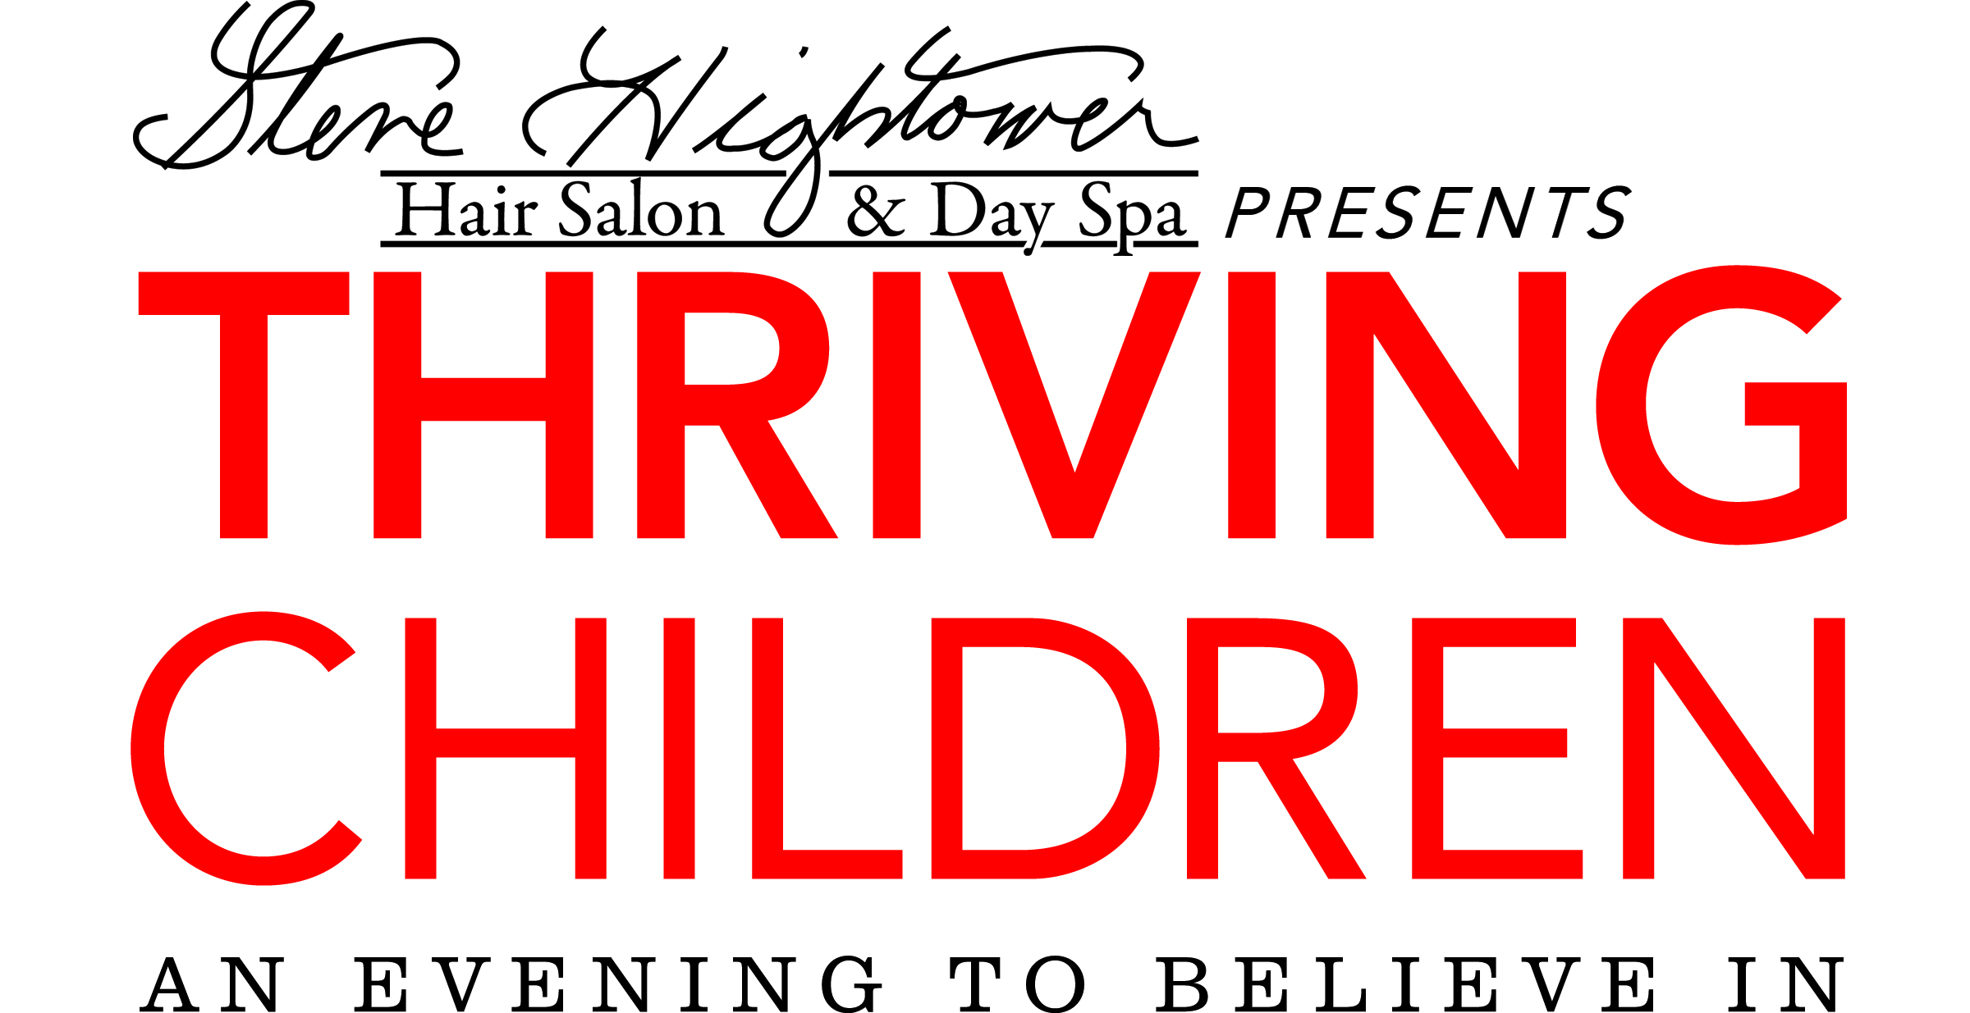
May 11th, 2018 • The Atlanta History Center
A benefit for
Lost-N-Found Youth
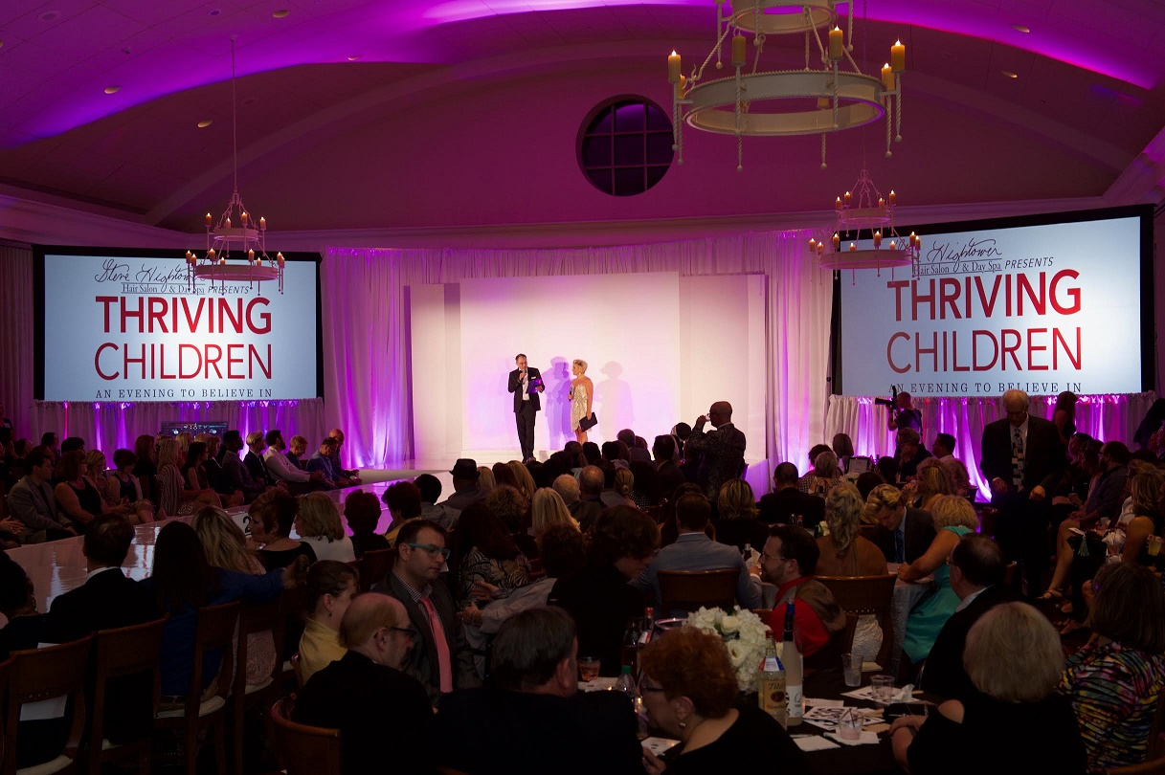

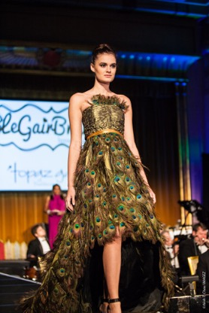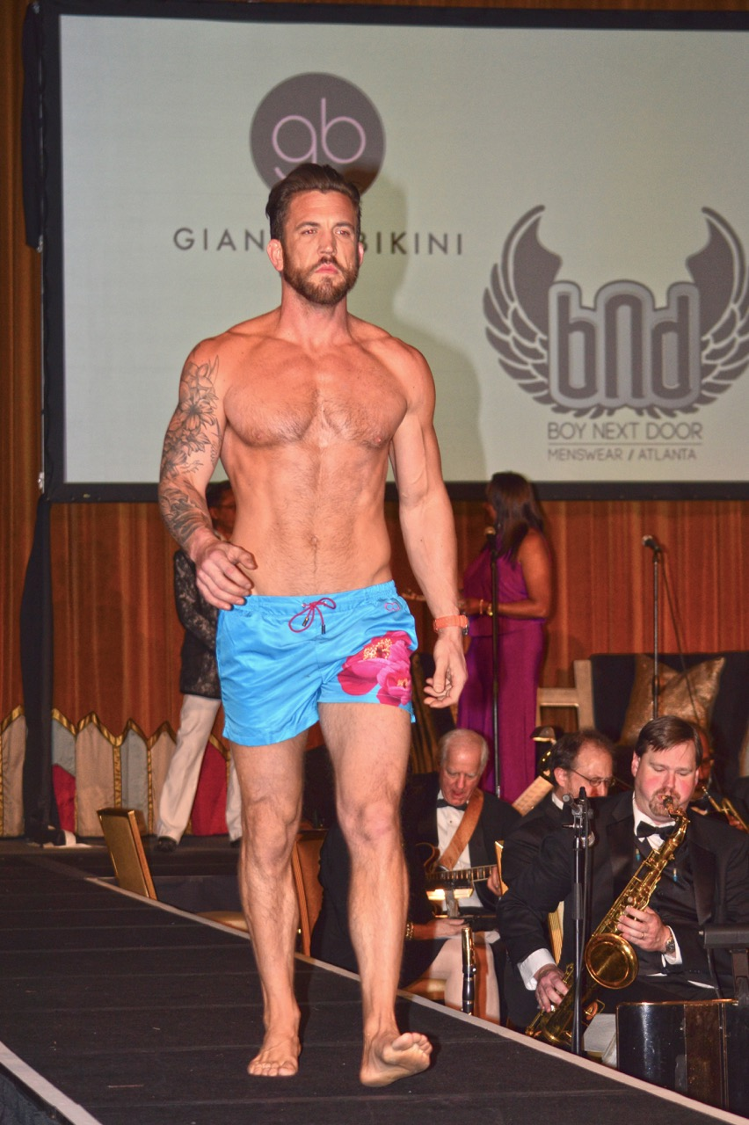
May 11th, 2018 • The Atlanta History Center
A benefit for
Lost-N-Found Youth

Now in its 9th year, the Thriving Children Fashion Show and Gala will be at the Atlanta History Center in the Atrium and Grand Overlook Ballroom.
The Benefiting 501(c)3 Organization:
Lost-N-Found Youth, Atlanta’s only non-profit organization dedicated to taking homeless lesbian, gay, bisexual and transgender youth off the street and into more permanent housing, Lost-n-Found Youth is dedicated to the advocacy and service of youth from 13 to 25 years old.

Lost-N-Found Youth provides a 24/7 hotline at
678-856-7825, a Youth Center, emergency housing, emergency clothing and food for youth on the street, mental health evaluations and counseling, Referrals to HIV/STD testing, health and dental services, Assistance for lost or stolen birth certificates, driver’s licenses or state ID cards, Referrals to GED training/testing and other education resources, Resume writing/editing and interview skills training, a 6-bed 90 day housing facility, and 3-6 month host home program.

Lost-n-Found Youth is a registered 501(c)3 organization with the U.S. Department of Revenue. Its Employer Identification Number is 45-4153322.
Donate online today at www.lnfy.org.
Over 85% of the funding goes directly to the homeless youth.

Our sponsors and supporters in 2017: Anderson Center for Hair & Aesthetics | Aventus Digital | Atlantan | BAI | Best Self | Bosley Scalp & Hair Care | Bridge Catering | Britt Wood Floral Design | The Cake Side of Things | Campagnolo | Catalyst Fitness | Catwalk Productions | Commonwealth Proper | David Whaley | DBA BBQ | Gardenology | George Jacob Gem Designs | Henry’s | Jane Iredale | Jezebel | Julian Williams | Jyl Craven | Kathleen Hammond | L’Oreal | Lindbergh | Mark Crispin- MDPC | Mark Nania | Mark Wright | Members Auto Choice | Modern Luxury | National Vision | Nina Gleyzer | One for You One To Give | Oribe | The Pig & The Pint | Prime Power | Publix | Q&A Events | Radial Café | Repechage | Sculpted Contours | Sentimental Journey Orchestra | Su So-Longman | Stacey & Don Leeburn | Taverna Plaka | Tim Timmons | Tito’s Handmade Vodka Jillian Williams | Tomas Duralde | Yvonne Monet Events | Zenagen

May 11th, 2018 • The Atlanta History Center
A benefit for
Lost-N-Found Youth
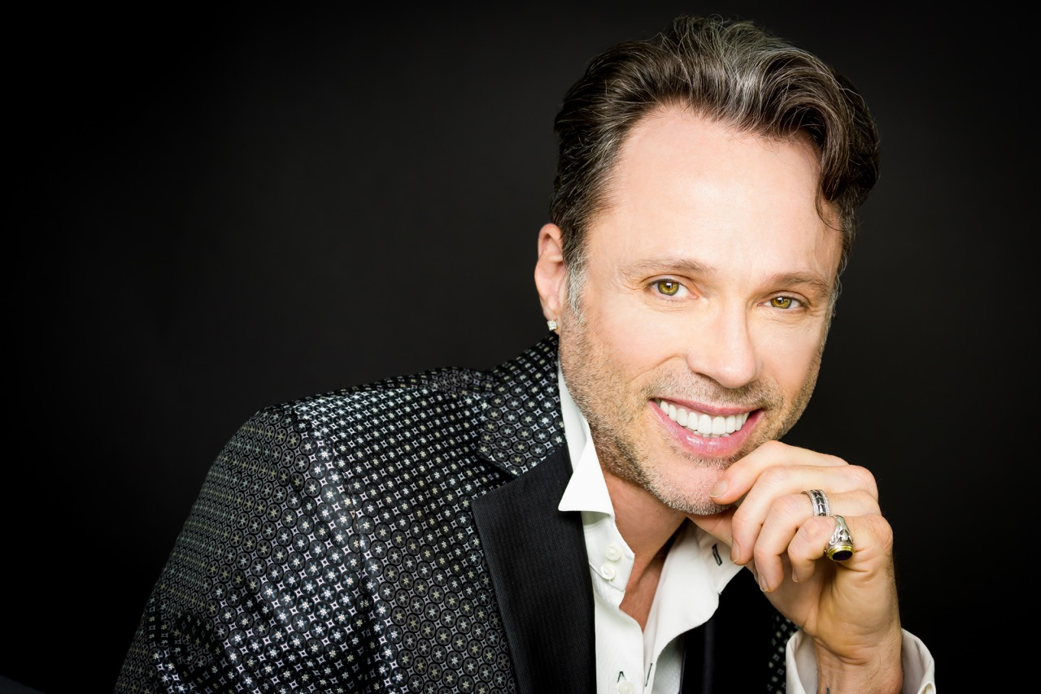
STEVE HIGHTOWER
Steve’s involvement with children’s charities and the annual fashion show began with something as simple as a request to collect and donate toys to children affected by a tornado in 2001 in his home state of Alabama. As Steve became more involved with children’s organizations here in Atlanta, he discovered there were children affected by HIV AIDS whose birth families gave them up because they couldn’t care for them.
As someone who has been HIV positive for over 20 years and healthy and undetectable due to excellent health care and support of family and friends, Steve felt very lucky and wanted to extend this support to medically fragile children and all children in need. Steve also has a nephew with Cerebral Palsy, and sees firsthand the constant needs for someone medically fragile.
As a successful business owner in Atlanta with a strong network of resources, Steve has been able to bring recognition and raise funds for the charities and for the children in need. He is proud that every year his efforts help more children and families. Steve says “I have been blessed and given so much and I am a firm believer of giving back. Give and you shall receive.”
Steve is an award winning hair designer and is recognized as one of the finest hairdressers in Atlanta, Georgia. Known for his passion and talent for hair, he has taught across the United States as a Platform Artist and National Educator. Steve has an extensive list of over 30 awards and honors that began in 1999. To name just a few:
Lost-N-Found Youth Board Member – 2017 - present
Atlanta’s Golden Heart Charity Award - 2017
Modern Luxury Weddings Diamond Award- 2017
Social Charity Datebook Spotlight Award - 2016
Over 40 & Fabulous Beauty Advisory Board Member – 2016 – Best Self
Best Hair Stylist 2015, 2016 - The Atlantan
Best Hair Salon for Her 2015, 2016, 2017 - Jezebel
Talk of the Town - Best Beauty & Day Spa 2012 -2017 - Celebration Media U.S.
The Talk Awards – Excellence in Customer Satisfaction - 2016
Best Salon 2012 & 2013, 2015 Kudzu
Best Female Hair Cut/Styling 2012 & 2013, 2015- Jezebel
Best of the City 2011 & 2012, 2015- The Atlantan
Member of Intercoiffure America & Canada 2013 & 2014 (Oscars to hairdressers; Invitation only)
Assistant to world-renowned fashion runway stylist Vivienne Mackinder (based in NYC) 2013 & 2014
Choice Salon for The Concierge Society of Atlanta 2013 & 2014
Sammy Award Top Salon of Atlanta 2012 - Spotlight Atlanta
Best Female Hair Cut/Styling 2012 - Jezebel
Best Hair Salon 2010 & 2011 - Citysearch
Best Overall Salon 2010 & 2011 – Jezebel
Global Entrepreneur, Hairdresser Top 80 finalist
Atlanta Consumer Choice Awards Number One Hairdresser
G-8 Summit First Lady Hairdresser
Atlanta Top 10 Salons
Biltmore National Registry of Who’s Who
Owner of Georgia’s only Mobil Guide 5 Star Salon, Steve Hightower Hair at Sea Island for 10 years
For more information on Steve, please visit www.SteveHightower.com
May 11th, 2018 • The Atlanta History Center
A benefit for
Lost-N-Found Youth
The Atlanta History Center
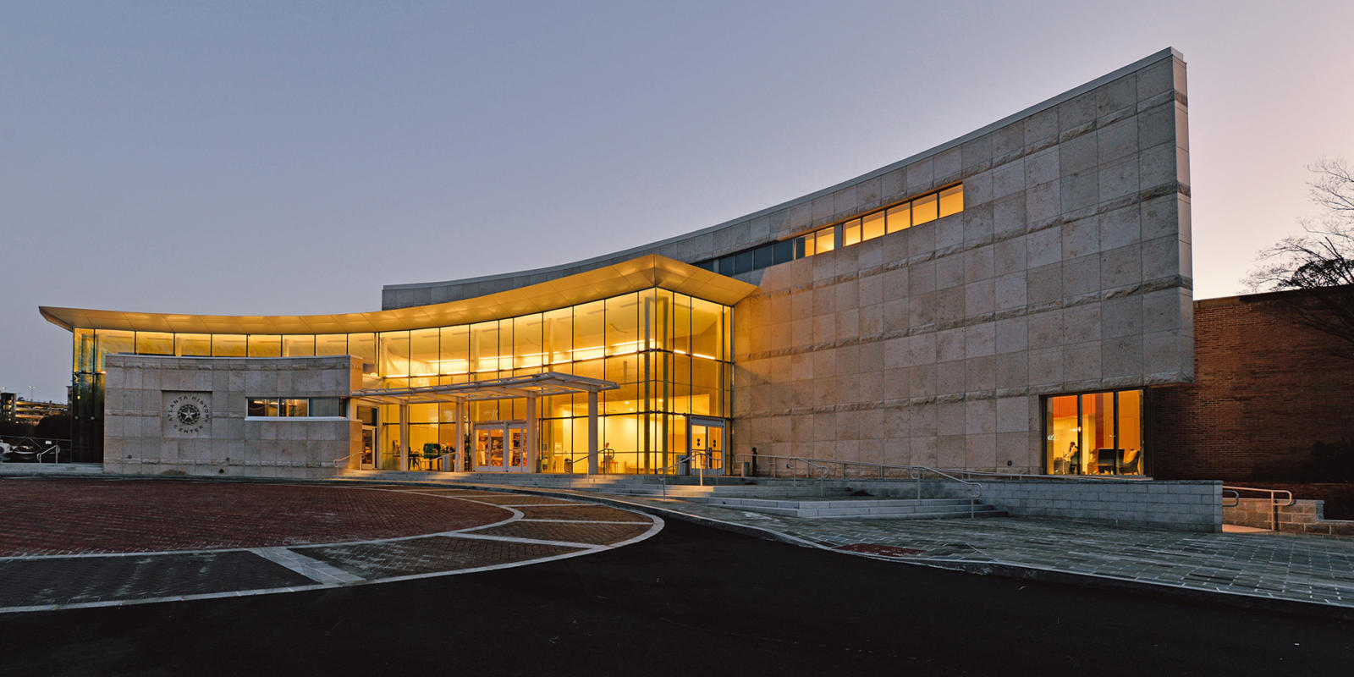
The Atlanta History Center is located in one of Atlanta’s most vibrant neighborhoods where the stories, mysteries and crusades of our region thrive. Our 33-acre experience features award-winning exhibitions, historic houses, enchanting gardens, interactive activities and a variety of year-round adult and family programs. Inside and outside of our buildings, we reveal the magic, meaning and context that gives rise to a multidimensional, shared understanding of our city. A world of history awaits you!

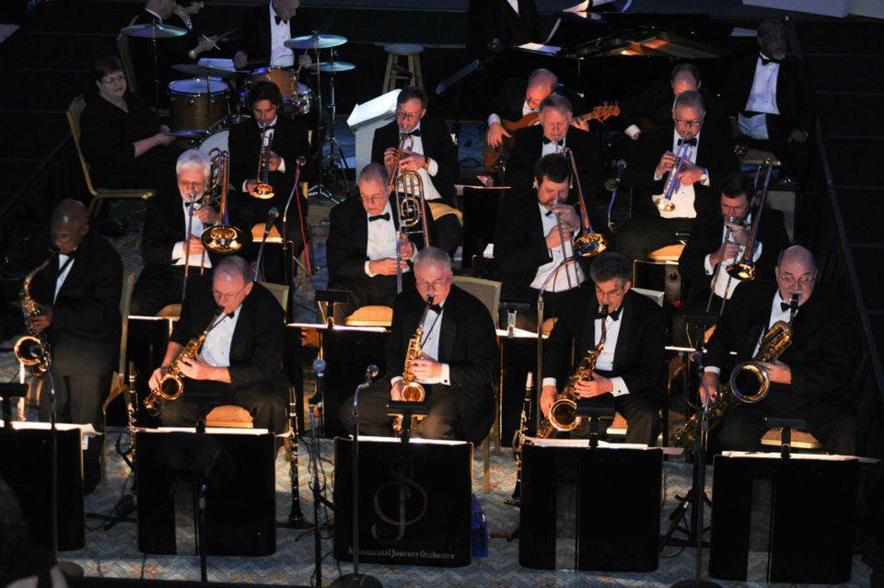
The Sentimental Journey Orchestra
For over 35 years, The Sentimental Journey Orchestra’s 18 musicians and 2 singers have been bringing the music of the big band era to audiences. The band performs arrangements recreating the sounds and styles of the most famous big bands: Dorsey, Miller, Basie, Brown, Goodman and Shaw. Their audiences are thrilled to listen and dance to arrangements of sambas, cha-chas, waltzes, tangos, and music made famous by Frank Sinatra, Michael Bublé, Ella Fitzgerald, and other vocalists.
Mistress of Ceremony
D’Anne Heckert – Modern Luxury Group Publisher
An Atlanta native, D’anne Cagle-Heckert graduated from Walton High School and then attended the University of Alabama, where she graduated with a double major in marketing and fashion design. She married her high school sweetheart, Sean Heckert, upon graduation and they will be celebrating their twelve-year anniversary in April. They are excited about the arrival of a baby girl in June 2016. Ce’zanne, who is definitely a “daddy’s little girl,” loves her swim and music classes.

D’anne’s long journey with Modern Luxury began with an internship with JEZEBEL magazine in 2003, where she proclaimed on her first day that the Publisher title was her ten-year goal. Almost exactly a decade later, D’anne was promoted to Group Publisher over all four Atlanta-based titles: The Atlantan, JEZEBEL, Modern Luxury Weddings Atlanta and Men’s Book Atlanta. She has been honored professionally with many awards including the University of Alabama’s prestigious Jack Davis Professional Achievement Award and the 2014 MAGS’ MAGnolia Award for management.

Mrs. Cagle-Heckert won the coveted mirror ball trophy for her dance performance and raised over $60,000 in donations for Dancing Stars of Atlanta in 2015 benefitting the Alzheimer’s Association, Georgia Chapter.
May 11th, 2018 • The Atlanta History Center
A benefit for
Lost-N-Found Youth

Special Entertainment Miss Coco Peru

Storyteller/monologist Miss Coco Peru aka Clinton Leupp got his/her start as a downtown favorite in the cabaret world of NY after he wrote, produced, directed, and starred in his first show over 20 years ago.
On screen, Miss Coco is best known for her roles in Jim Fall's feature film, trick (Sundance 1999) and Richard Day's Girls Will Be Girls (Sundance 2002). Other film appearances include To Wong Foo, Thanks for Everything, Julie Newmar, and Straight-Jacket. Coco can be heard in the Disney animated feature, The Wild as Mamma Hippo! She also appears in the highly-ish anticipated sequel of Girls Will Be Girls which will be released some day, hopefully.
Coco has appeared on TV in two stand-up comedy specials on LOGO: Wisecrack and Dragtastic, Not Today, Bianca (with Bianca Del Rio),How I Met Your Mother, Arrested Development, Twins, Will and Grace, New York Undercover, Detroit 187, several Bravo reality and clip shows, and in an Orbitz commercial that was nominated for a GLAAD Media Award.
Coco’s live one-person shows have been performed to sold out audiences in Theatres, Clubs, Restaurants, Ballrooms and Cabarets throughout the US and abroad. Coco hosts an on-going live series of shows at the Renberg Theater in Los Angeles called Conversations With Coco in which Coco interviews and celebrates the lives and careers of the LGBT community's favorite icons. Miss Peru's guests include Liza Minnelli, Jane Fonda, Bea Arthur, Lily Tomlin, Karen Black, Lainie Kazan, Lesley Ann Warren, and drag legend Mr. Charles Busch. After a very successful Kickstarter campaign, a television pilot of Conversations with Coco was recently taped with her guest, Lily Tomlin and is currently being shopped around to networks.
Coco’s recent online Youtube videos have been seen by over 3 million viewers. Her video “Coco Goes to KMART,” in which she searches for Celestial Seasoning Tension Tamer tea, has over 1 million views.

May 11th, 2018 • The Atlanta History Center
A benefit for
Lost-N-Found Youth
2018 Sponsorship Opportunities

Angel - $10,000
6 VIP tickets & 6 regular ticket / 6 VIP swag bags
● Prominent listing in Atlanta magazines
● Listing in event program and stage announcement ● Company name and logo on event publicity and signage
● Company name and logo on Steve Hightower and benefiting agency’s website
● Company name and logo on stage screens
● Email blasts hosted by participating Atlanta magazines and Steve Hightower Hair Studio
Guardian – $5,000
4 VIP tickets & 4 regular tickets / 4 VIP swag bags
● Prominent listing in Atlanta magazines
● Listing in event program
● Company name and logo on event publicity and signage
● Company name and logo on Steve’s and benefiting agency’s website Company name and logo on stage screens
● Company name and logo on stage screens
● Email blasts hosted by participating Atlanta magazines and Steve Hightower Hair Studio

Protector – $2,500
2 VIP tickets & 4 regular tickets / 2 VIP Swag Bags
● Company name on event publicity
● Name in event program
● Company name on Steve Hightower and benefiting agency’s website
● Company name and logo on stage screens

Partner – $1,500
2 VIP & 2 regular tickets / 2 VIP Swag Bags
● Name in event program
● Company name on Steve Hightower and benefiting agency’s website

Best Friend – $1,000
4 Regular tickets
● Name in event program
● Company name on Steve Hightower and benefiting agency’s website

Friend – $500
2 Regular tickets
Name in event program

May 11th, 2018 • The Atlanta History Center
A benefit for
Lost-N-Found Youth
2018 Sponsor Commitment Form

Sponsoring Organization Name: ____________________________________________
Contact Name: __________________________________________________________________
Sponsorship Level: _____________________________________________________________
Make check payable to: Lost –N–Found Youth,
Memo: “Thriving Children”

Check number: ___________________________
OR
Credit Card (circle one): AmEx Discover Master Card Visa
Number: ______________________________________________________ Exp. _______________________
Billing Address: __________________________________________________________________
__________________________________________________________________
__________________________________________________________________

Please mail form and payment to:
Thriving Children Gala
c/o Lost-N-Found Youth
2585 Chantilly Drive
Atlanta, GA 30324

Lost-n-Found Youth is a registered 501c3 organization with the U.S. Department of Revenue. Its Employer Identification Number is 45-4153322.

May 11th, 2018 • The Atlanta History Center
A benefit for
Lost-N-Found Youth

2018 Gala and Ticket Information
6:30 – Doors Open
Silent Auction
Cocktails
Hors D'oeuvres – from Atlanta’s Top Caterers / Restaurants
Sentimental Journey Orchestra

7:45 – Seated Show in Grand Overlook Ballroom
Mistress of Ceremony
D’Anne Heckert – Modern Luxury Group Publisher
New York Style Runway Fashion Show
with Professional Models
Fashion from Top Atlanta’s Elite Designers

Guest Youth Speakers from Lost -n- Found Youth

Live Auction

Special Entertainment

Tickets

General Admission Tickets
$75

VIP Tickets
(Includes Reserved Assigned Seating, VIP Swag Bag)

VIP $175 / Each ● $300 / Pair

VIP Table for 4
(Includes 1 Bottle Tito’s Vodka & Mixers, Designated Waiter/ Table Runner)
$850

VIP Table for 10
(Includes 2 Bottles Tito’s Vodka & Mixers, Designated Waiter / Table Runner)
$2000

May 11th, 2018 • The Atlanta History Center
A benefit for
Lost-N-Found Youth
2018 Auction Donation Form
Item(s) Donated: __________________________________________________________________________________
Description: __________________________________________________________________________________
__________________________________________________________________________________
Value: $______________________________________

Contact Name: ______________________________________________________________
Company/Organization: _______________________________________________________________
Address: ________________________________________________________________
_________________________________________________________________
_________________________________________________________________
Phone: ____________________________________ Email: _________________________________________________
□ Name / Organization to appear on Auction Item Bid Sheet ___________________________________________
□ Anonymous to appear on Auction Item Bid Sheet
Items may be mailed along with this form to:
Thriving Children Gala
c/o Lost-N-Found Youth
2585 Chantilly Drive
Atlanta, GA 30324

Or to arrange for pick-up/drop-off, contact Rick at (770) 485-1639; rick@lost-n-found.org
Lost-n-Found Youth is a registered 501c3 organization with the U.S. Department of Revenue. Its Employer Identification Number is 45-4153322.

